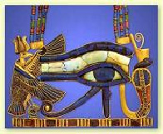

Please join us for this fascinating and eventful evening.

Learn How Color and Oils Enhance your Spirit

Based on an ancient Egyptian ritual described in the Temple of Isis for “cleansing the spirit”, we will be asking for volunteers to experience this amazing emotional clearing technique.
Learn how colour and oils have similar electromagnetic vibrations and how they positively affect human beings. In today’s tough economic times, stress levels have reached an uncomfortable level and this information on colour and therapeutic grade essential oils will enhance your wellness and ability to cope with today’s living.

Presented by Anjel OBryant, MDIA; Michael Dale, Greg Degenhardt

A Southern Cross Academy evening.

Venue: Uniting Church, Cnr Yeo and Barry Streets, Neutral Bay
(Entrance via Barry Street).

Date: Monday, 3rd August 2009 at 7.15pm for 7.30pm sharp

Cost: $15 admission; $10 for pensioners/students.
Tea, coffee and biscuits provided

